978-1-4673-8855-9/17/$31.00 ©2017 IEEE

Design of an Intelligent adaptive path tracking and collision avoidance of mobile robot

Authors Name/s per 1st Affiliation (Author)
line 1 (of Affiliation): dept. name of organization
line 2: name of organization, acronyms acceptable
line 3: City, Country
line 4: e-mail address if desired
Authors Name/s per 2nd Affiliation (Author)
line 1 (of Affiliation): dept. name of organization
line 2: name of organization, acronyms acceptable
line 3: City, Country
line 4: e-mail address if desired

Abstract—Mobile robots are machines which are capable of locomotion. A differential drive robot can be used for the application of land mine detection which is the main focus of this paper. A switching path planning control scheme is proposed which switches between the path tracking and obstacle avoidance control, helps the robot in efficiently reaching the target avoiding the obstacles in the unknown environments with less memory size. For tracking, the Carrot Chasing Algorithm is used. In obstacle avoidance, an algorithm is designed using the sensors and obstacle position. Intelligent adaptive schemes are used to avoid the uncertainties from external environment and sensor noises which give way to more adaptive and easier approach. Thus, for obstacle avoidance, fuzzy logic controller using Tagaki- Sugeno model is designed. The variation in sensor inputs is indicated in terms of distance. This distance is taken as one of the inputs while designing the fuzzy. Thus, the sensor variation indicated as distance variation is minimized using fuzzy design. Combined tracking with obstacle avoidance is simulated using MATLAB software. The combination of tracking with obstacle avoidance using fuzzy gives a result with smooth deviation from obstacle with perfect tracking than the combination of tracking with obstacle avoidance algorithm.
Keywords—tracking; fuzzy; obstacle avoidance; TagakiSugeno; intelligent;

INTRODUCTION
Robotics can be described as the current pinnacle of technical development. The robot arm can move with great speed and accuracy to perform various repetitive tasks. But these suffer from the lack of mobility which is rectified by the mobile robots that enables locomotion, classified as Unmanned Ground Vehicle (UGV), Autonomous Ground Vehicle (AGV) etc. The mobile robots have established various technical improvements in the field of robotics where the major challenge faced is obstacle avoidance, the highlight of this investigation. The main aim of this research is not only to develop a robot that is efficient in reaching the target by avoiding the obstacles with less memory size using more adaptive and easier approach, but also to implement it in various applications such as landmine detection, which is the major focus of this paper.

LITERATURE SURVEY
Yoshio Yamamoto and Xiaoping Yun [1] proposed a control algorithm for the platform so that the manipulator followed by the mobile platform is positioned at the preferred configurations measured by its manipulability. Of the two main methods of modelling, Lagrange method is used to develop the dynamic model in which the basic lagrangian is defined as the difference between kinetic energy and potential energy. Since the mobile robot is a ground vehicle, the potential energy is considered as zero. The energy is given as total kinetic energy [7],
T= (2.1)
where,
(1/2)M= (1/2)M(+) (2.2)
(2.3)
= (1/2)+ (1/2) (2.4)
- Kinetic energy due to pure translation of vehicle
Kinetic energy of rotation of vehicle
- Kinetic energy of rotation of motors and wheels
On applying lagrangian equations,
() - () =0 (2.5)
() - () =0 (2.6)
() - () =0 (2.7)
() - () = (2.8)
() - () = (2.9)
where and are right and left actuation torques
The state variables [1] considered for the mobile robot are,
q= (2.10)
in which position coordinates, Φ is the orientation of mobile robot and are angular position for the left and right driving wheels.
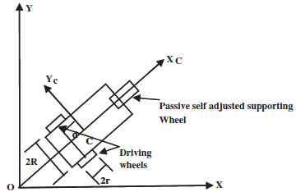
Figure 2.1 Orientation of mobile robot
Figure 1.1 shows the orientation of mobile robot [1]. The two main non holonomic constraints [1] considered for the robot are:
- Platform motion in the direction of axis of symmetry ie,
(2.11)
- Rolling constraints for left and right wheels are given by the equations,
(2.12)
(2.13)
Then the above three constraints can written as
A(q)=0 (2.14)
where,
A(q) = 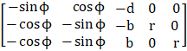
On writing the five equations of motion in state space representation
M(q)+V(q,)=E(q)τ-λ (2.15)
where, M(q) is the N x N inertia matrix, V(q,) is the N x 1 vector of position and velocity dependent forces, E(q) is the N x r input transformation matrix, and τ is the r dimensional input vector.
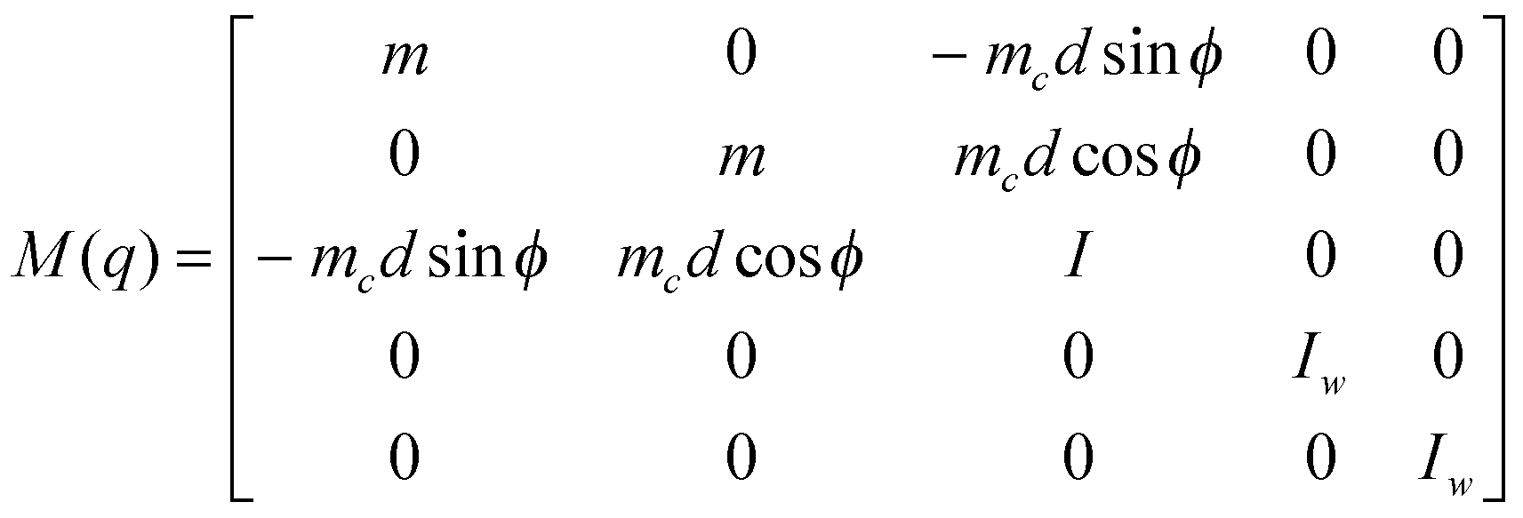

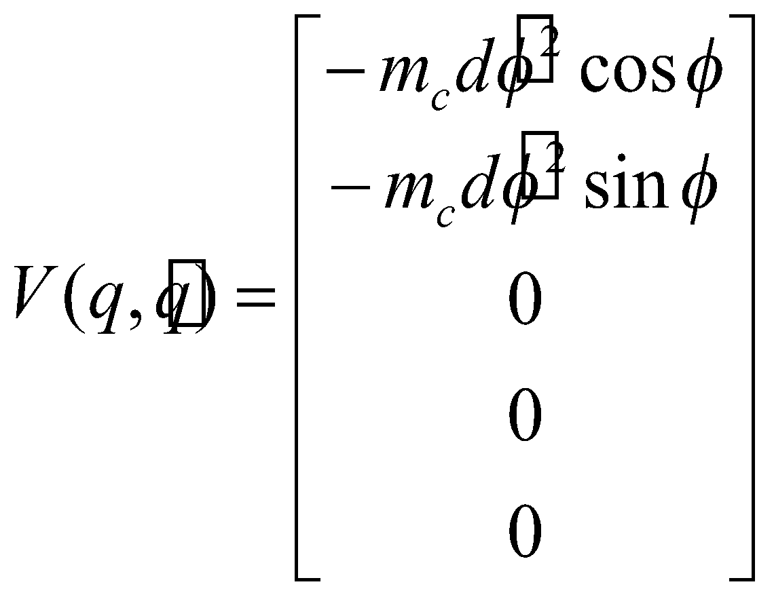
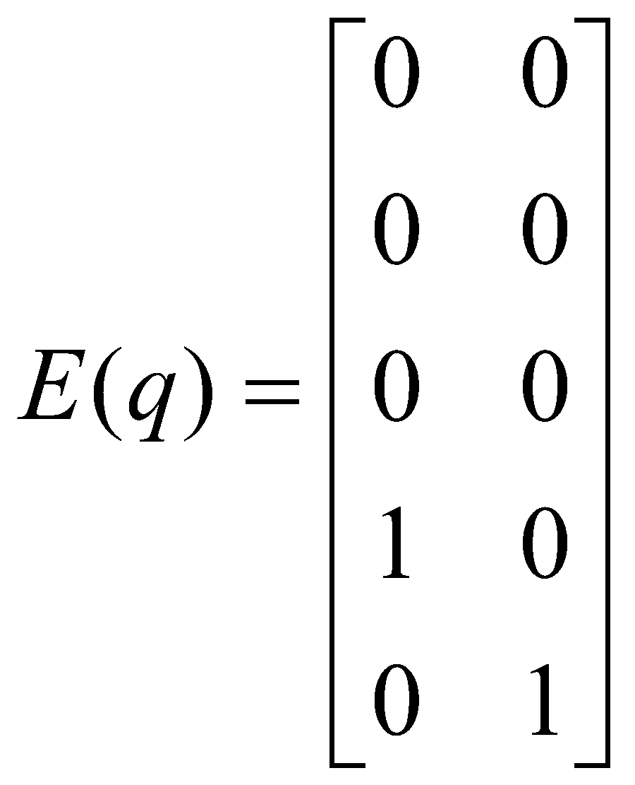

M. Wang, J.N.K. Liu [2] explained memory grid map, which uses the principle of minimum number of obstacle and trajectory memory dots decides the shortest path using Mamdani inference system and defuzzification method , facing the disadvantage of high power consumption and time consuming to reach the target.

W.L. Xu , S.K. Tso [3] used the principle of reactive robot navigation where target attracts the robot, while the obstacle repels it. Here, sensed ranging signals and relative target positions are fuzzy inputs and steering angle and velocity change of robots are fuzzy outputs. The robots gains fast decision making but it lacks to reach the goal in concave and recursive U -shaped points.
G.Antonelli , S.Chiaverini , G.Fusco [4],used actual – virtual target switching scheme where the sum of all turning angles should be near to .It solves the problem of limit cycles at the multiple dead end traps but it fails at G shaped points.

Rong-Jong Wain, Chia-MingLiu, You-WeiLin [5], designed a switching path planning control scheme which use separately designed modes. This provides better target tracking efficiency, less time consumption, works efficiently in all unknown environments, less computational burden but moving obstacles cannot be avoided, and the sensor noise may lead to uncertainty.

TRACKING
Path planning is the process of obtaining an optimum path for the mobile robot from the current location to the desired target location using path following algorithms [6].Using Virtual Target Point(VTP) on the path, the mobile robot can easily chase it ,thus follows the path as time progress. This algorithm, also known as carrot chasing algorithm or missile chasing algorithm [6] is simple to implement but it has a limitation that it is not robust to large disturbances.

Wheeled Mobile Robot
Fig.3.1 shows the schematic diagram [5] of differential drive wheeled mobile robot with two driving wheels which independently driven by two actuators and the caster. Here, the pure rolling and non-slipping condition states that this mobile robot can only move in the direction normal to the axis of the driving wheels and also assumed that this mobile robot is equipped with non-deformable wheels, and they are moving in a horizontal plane.
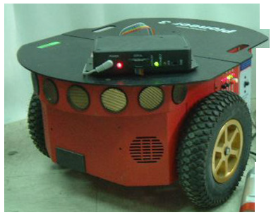
Figure.3.1 Schematic of a wheeled mobile robot

Path Following Problem
Given a path, initial location p = (x, y) of the mobile robot along with its heading angle (ψ), the path following problem is to determine the commanded heading angle () for the vehicle such that by following (), the mobile robot accurately tracks the path as the mission progresses. The straight line paths [6] can be defined as a set of waypoints. Assume that the mobile robot is at a distance d from the path. This distance d is called as cross track error. The main objective of path following algorithms is to minimize the cross track error, d and |ψ-θ|🡪 0 as the mission time t 🡪∞.

Straight Line Following

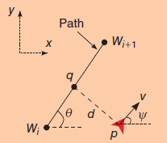
Figure 3.2 Straight line path following
A straight-line path [6] is denoted by two waypoints and, as shown in figure 3.2. A straight line involves following steps:
1) Determine the cross-track error (d)
2) Update the location of the VTP
Assume the mobile robot is at location p with heading angle ψ. The projection of p onto the LOS is the point q at a distance R from is the cross-track error d. The angle formed by waypoints W and is called the line-of-sight (LOS) angle (θ).

Algorithm for Straight Line Following

In figure 3.3, a straight-line path is denoted by two waypoints and.A straight line involves following steps:
1) Determine the cross-track error (d)
2) Update the location of the VTP
Assume the robot is at location p with heading. The projection of p onto the LOS is the point q at a distance R from is the cross-track error d. The VTP (s = ()) is located at a distance d from q. The robot desired heading ϕ is updated based on the location of s. This process continues until the robot reaches. The procedure to update the location of VTP and is given in the below algorithm. The control input u uses a proportional controller with gain k > 0.
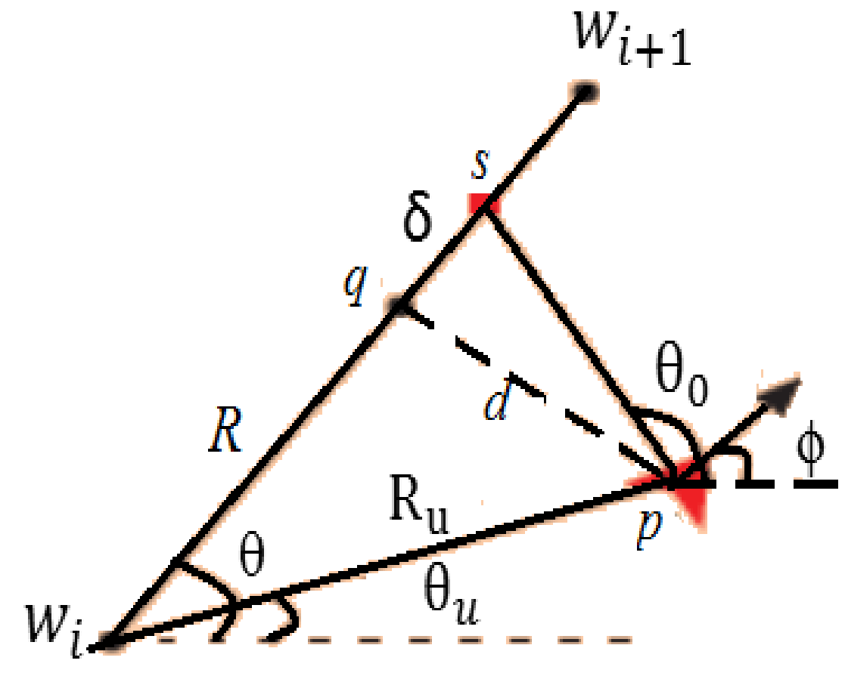
Figure 3.3 Straight line path followed by mobile robot using carrot chasing algorithm
1: Initialize:=(), p=(),
2:= ||-p||, θ=atan2 ()
3: = atan2 (yc-, xc-) ,β=θ-
4: R = 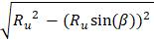
5: () = ((R+δ), (R+δ))
6:theta0=atan2d ((yt-yc), (xt-xc));
7: Xr = xc+dn*cosd (theta0);
8: Yr = yc+dn* sind (theta0);
The path parameter δ can modify the performance of the carrot-chasing algorithm. For low δ, the mobile robot is forced to move directly towards the LOS. A trajectory to the path that is normal to the path will result in overshoot resulting in higher cross-track error. With an increase in δ, the robot is able to settle on the path quickly, reducing the cross-track error. However, for even larger values of δ, the cross-track error again increases.
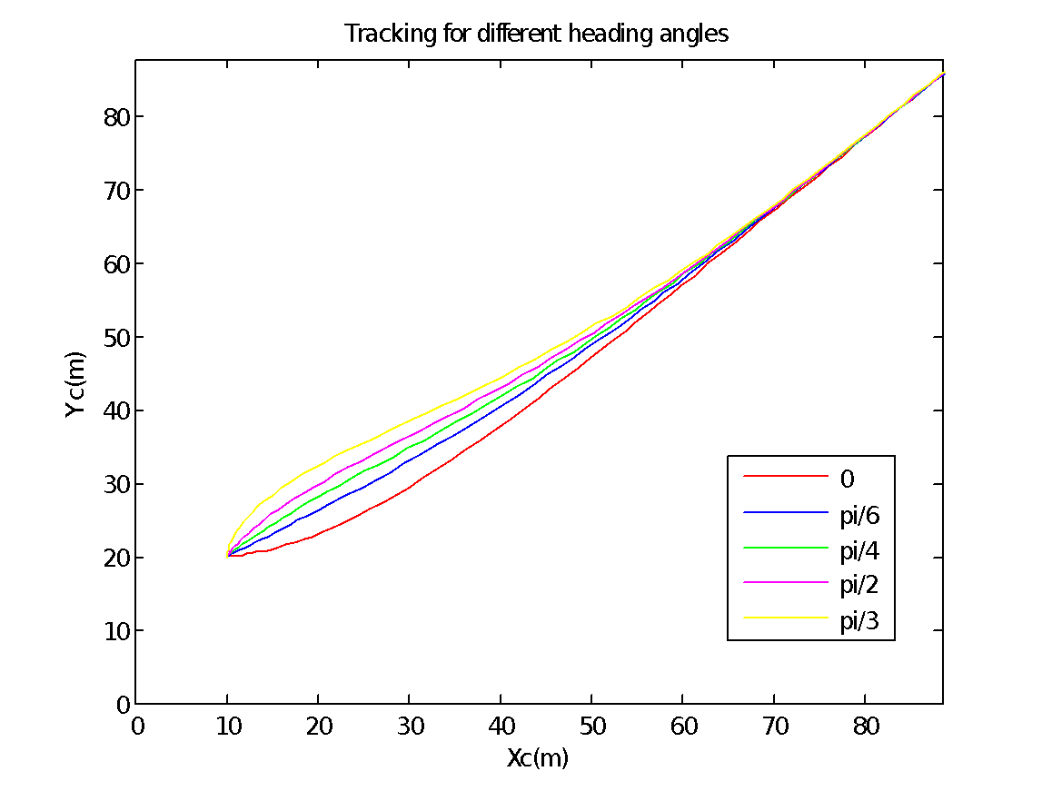
Figure 3.4. Tracking performance for different ϕ
Simulation result for tracking of mobile robot for different heading angle is shown in figure 3.4.

Tracking Control
The control input u is the torque produced. The error dynamics [1] is responsible for the tracking of robot to the desired path. So we could use the desired path y^{d} feedback the error 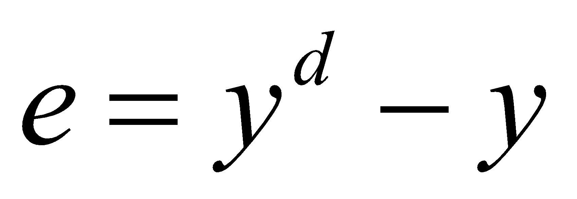.
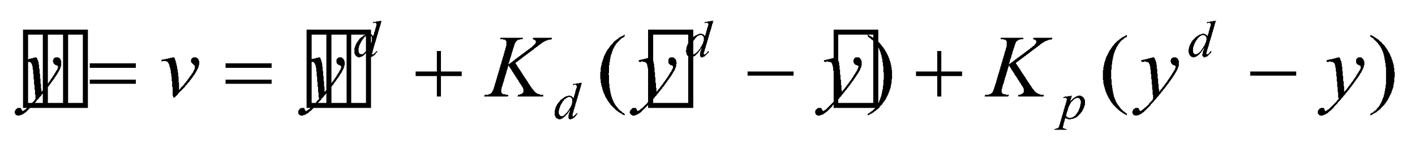 (3.1)
Characteristic equation of the differential equation (3.1) [1] is obtained and gains are selected so that roots are real and negative. When characteristic equation has negative real roots, the error will reduce to zero. k_{p} and k_{d} values are chosen such that the error value is minimum and it gives perfect tracking. Figure 3.5 shows the tracking performance of mobile robot. The pink line shown in the graph is the desired path whereas the blue line is the mobile robot path.

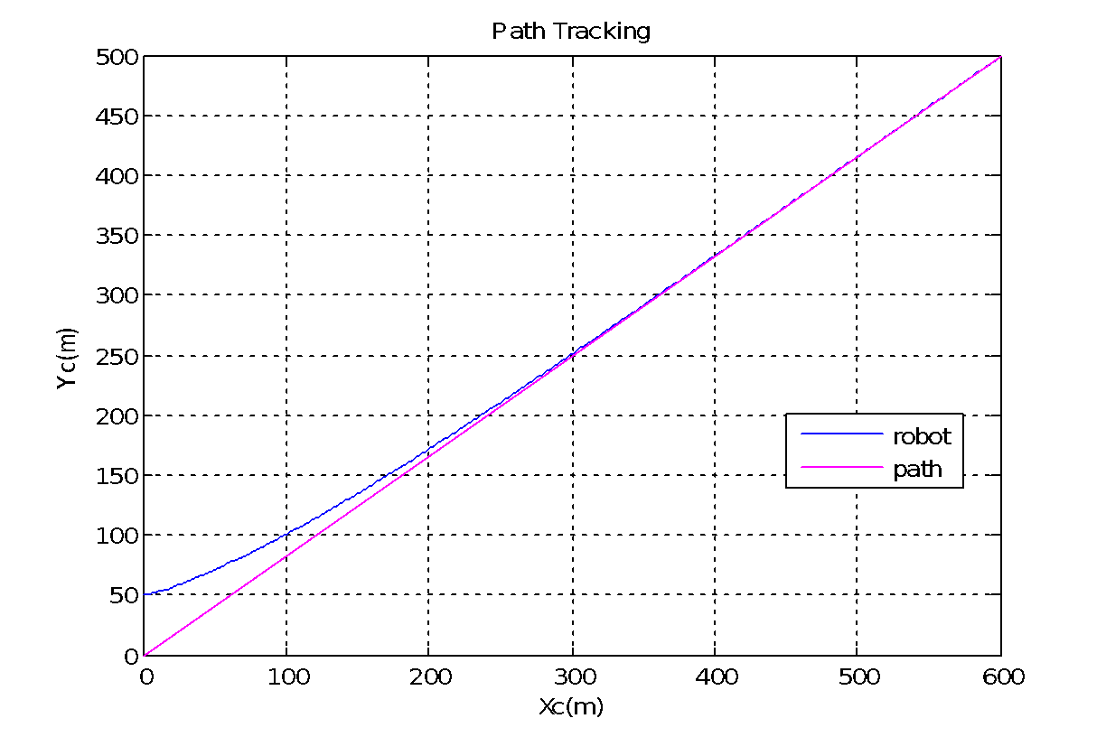
Figure 3.5. Tracking of mobile robot for a straight line

Loiter Following
Figure 3.6 shows the loiter [6] maneuver in which the mobile robot circles around a point (O) with a standoff distance of r. The mobile robot located on the circle and heading orthogonally to r performs the loiter either clockwise or counter clockwise. Assume the mobile robot is located at p. The cross-track error is d = O -p -r. Using the cross-track error information and the direction of the loiter, the VTP location can be generated.

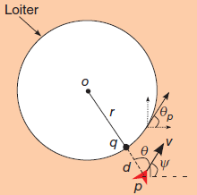
Figure 3.6 Loiter path following

Algorithm for Loiter Following
CCA [6] is used in the algorithm explained below.
1: Initialize O=(), r, λ
2: θ = atan2(y-, x-)
3: (,) = (rcos(θ+λ), rsin(θ+λ))
4: =atan2 (-y, -x)

The performance of the carrot-chasing algorithm [6] depends on the value for λ. When λ =0, the mobile robot is unable to track the path as the desired VTP always points orthogonal to the robot position thus performs a sinusoidal path along the loiter. When λ is increased, the VTP is in the pursuit range, and hence the vehicle is able to track it quickly. The tracking of loiter by mobile robot is shown in figure 3.7.
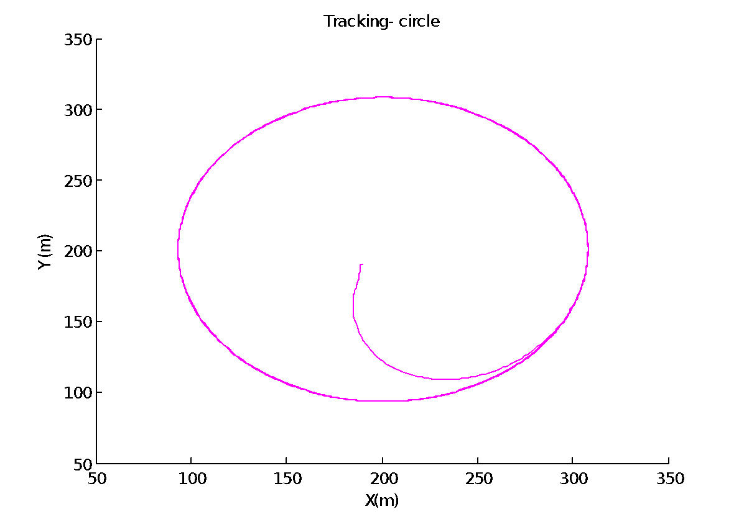
Figure 3.7. Loiter tracking using CCA algorithm

OBSTACLE AVOIDANCE

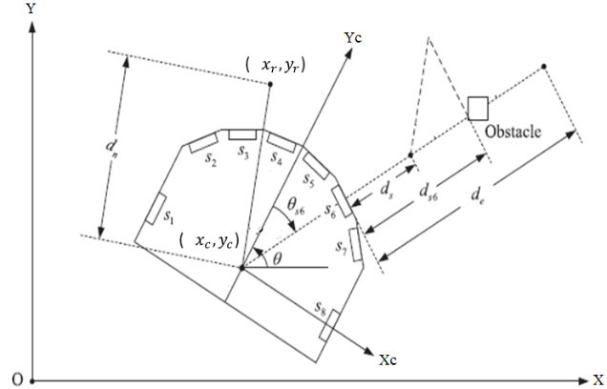
Figure 4.1 Orientation of sensors on the mobile robot

The obstacle avoidance algorithm is designed based on the orientation of the sensors attached to the mobile robot by indicating difference in the distance measured.

Obstacle Avoidance Algorithm
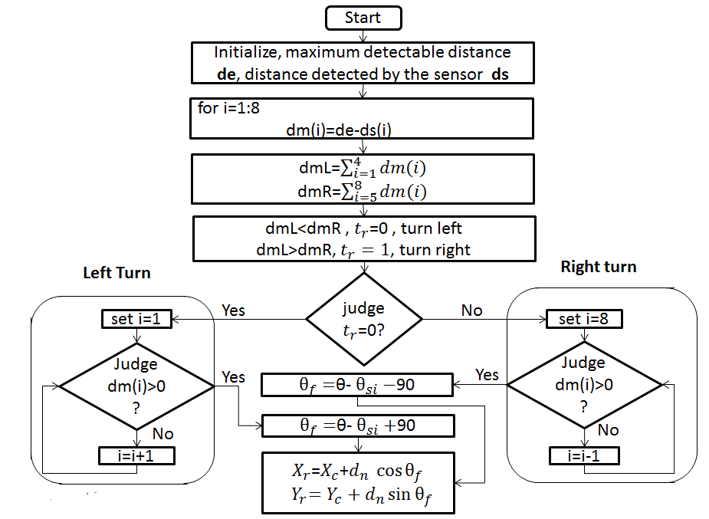
Fig 4.2.Flow chart of obstacle avoidance algorithm.
When the obstacle around the robot is detected, the right/left command index (tr) can be expressed as:

If < , then tr =0. (4.1)

If > , then tr= 1 (4.2)

If condition (4.1) holds, it means that the obstacle is close to the right side of the robot , then tr = 0 to make the robot turn left to avoid the obstacle. On the other hand, tr = 1 to make the robot turn right to prevent collision if the condition (4.2) holds. The sum of distances decides to where the mobile robot should turn to avoid obstacles. The heading angle is given by the equations:
, for right turn (4.3)
, for left turn (4.4)
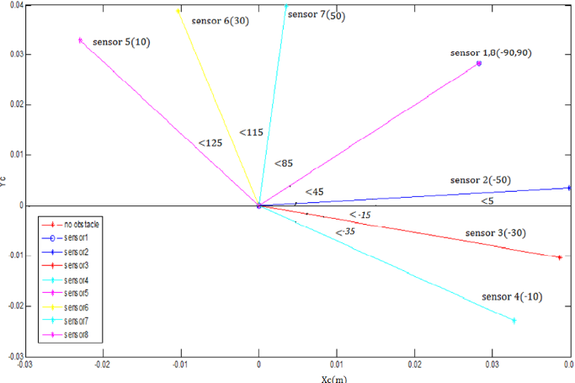
Figure 4.3 Obstacle avoidance using algorithm and the corresponding
heading angles
In Figure 4.3, as an obstacle is detected at sensor 3, at an angle of the robot changes its heading angle and travels through the red line at an angle of from the reference axis. This result is obtained using the obstacle avoidance algorithm [5].

Obstacle Avoidance using T-S Fuzzy Inference System
Fuzzy helps in minimising the noises produced by the sensors while detecting the obstacle. Tagaki- Sugeno inference system is used to frame the rule base.

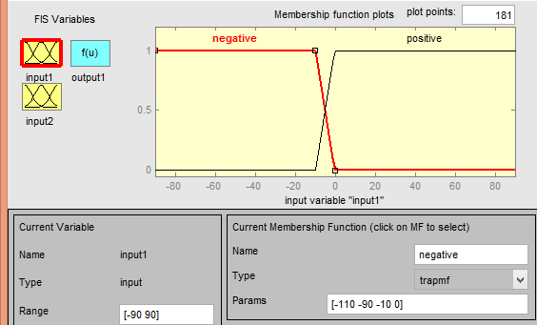
Figure 4.4. Fuzzy input-
and d are taken as the two fuzzy inputs.
Two trapezoidal membership functions, NEGATIVE (N) in the range [-110 -90 -10 0] and POSITIVE (P) in the range [-10 0 90 110] are taken as the input shown in the figure 4.4.

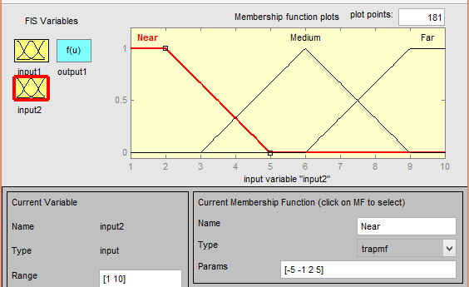
Figure 4.5. Fuzzy input – d
For the second input to fuzzy, NEAR (N)-a trapezoidal membership function in the range [-5 -1 2 5], MEDIUM (M)- a triangular function in the range [3 6 9] and FAR (F) – a trapezoidal membership function in the range [6 9 10 10] are taken.

d | N | M | F
P | mf1 | mf3 | mf5
N | mf2 | mf4 | mf6
Table 4.1. Fuzzy Rule Base
From Table 4.1, if the fixed angle of the sensor is positive and the distance is near, the output which is activated is mf1 and likewise move on for various conditions. The output membership functions are described as: mf1= [-1 0 90]; mf2= [-1 0 -90]; mf3= [-0.8 0 72]; mf4= [-0.8 0 -72]; mf5= [-0.6 0 54]; mf6= [-0.6 0 -54]; where, this 1, 0.8 and 0.6 are the fraction of distance considered for near, medium and far respectively.
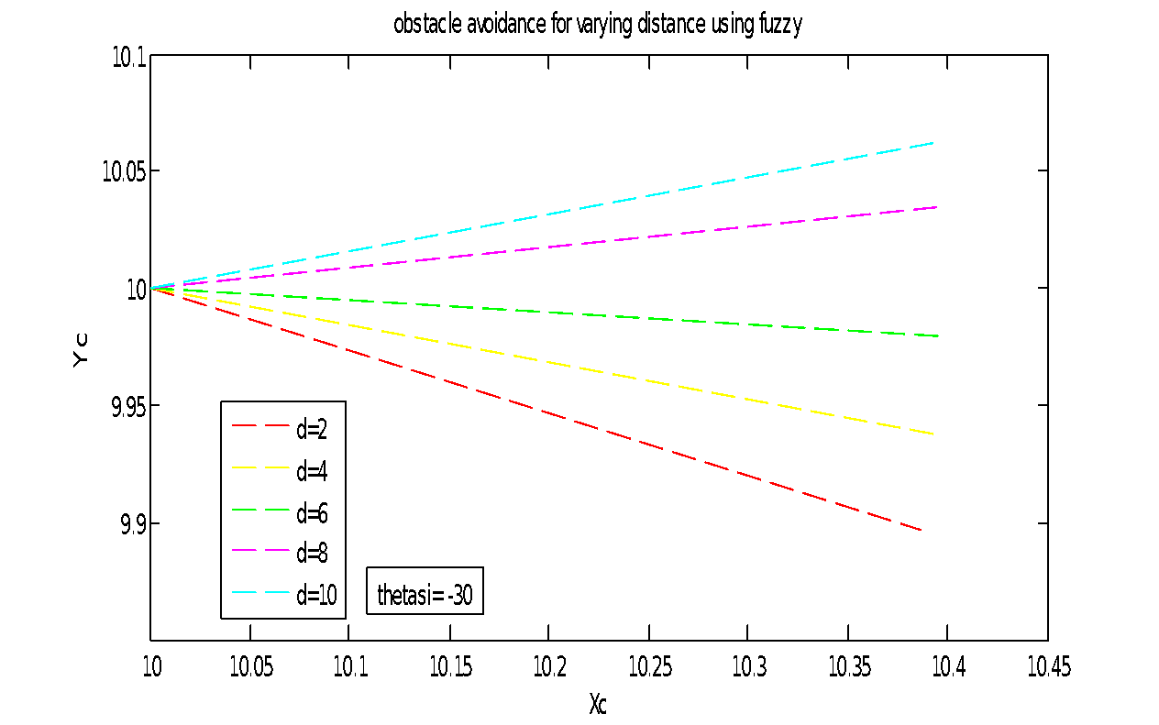
Figure 4.6. Deviation of robot with variation in presence of the obstacle.

From figure 4.6, the logic used is that if the obstacle is present at a distance near, medium or far to the mobile robot , then the deviation taken by the robot will be maximum(red line), medium(green line) or small(blue line) respectively to avoid the obstacle.

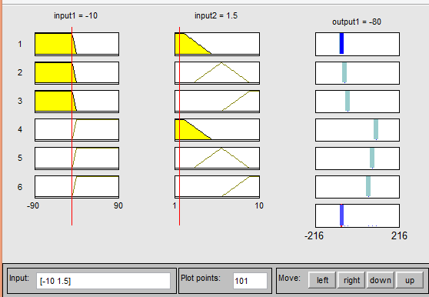
Figure 4.7. Output calculation for two particular inputs
Figure 4.7. shows that after avoiding the obstacle which is at 1.5 distance from sensor 1 (-10), the robot will head in the direction of (-80+45)=(-35) from the reference axis.

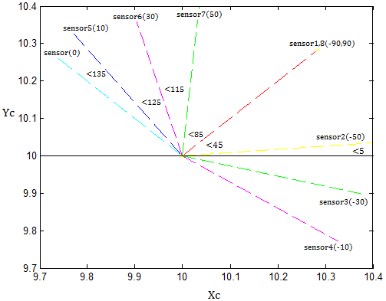
Figure 4.8.Obstacle avoidance using fuzzy design.

Figure 4.8 tells that as an obstacle is detected at sensor 5, at an angle of , the robot changes its heading angle and travels through the blue line at an angle of from the reference axis where the initial heading angle being for each sensor.

LOCOMOTION OF MOBILE ROBOTS

Locomation using Obstacle Avoidance Algorithm

Figure 5.1 shows the simulation result for tracking with obstacle avoidance using CCA [6] and obstacle avoidance algorithm [5] in which the green line shows the desired path, blue dots indicates the obstacles and the pink line shows the tracking with obstacle avoidance.

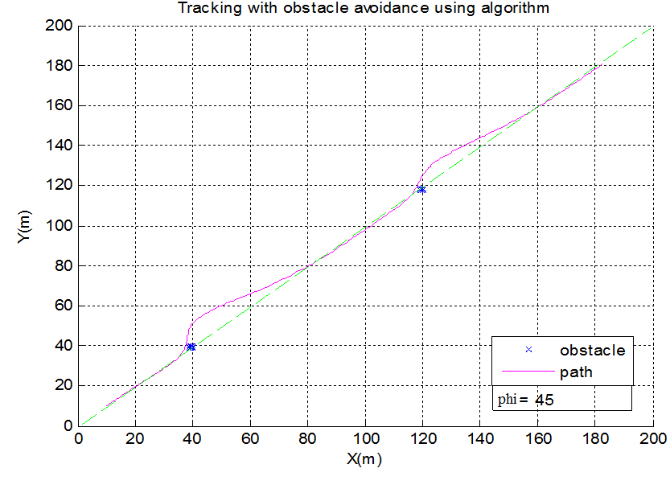
Figure 5.1. Tracking with obstacle avoidance algorithm.

Locomation using fuzzy logic

Figure 5.2 shows the simulation result for tracking with obstacle avoidance using fuzzy logic in which the green line shows the desired path, blue dots indicates the obstacles and the pink line shows the tracking with obstacle avoidance.
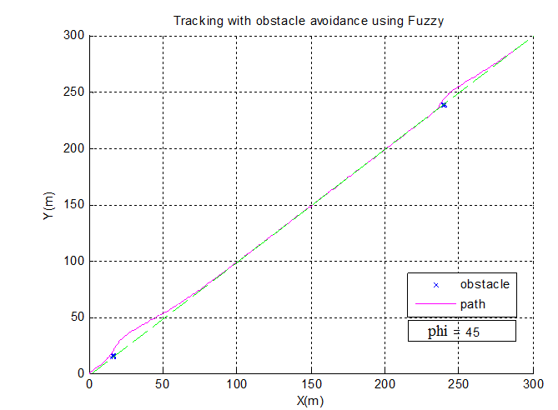
Figure 5.2. Tracking with obstacle avoidance using fuzzy logic

Comparison of Locomation using Obstacle Avoidance Algorithm and Fuzzy

Figure.5.3 implies that the deviation of fuzzy path is much less compared to the algorithm path and the memory size is less since the obstacle or the path is not saved. The time taken by the fuzzy path to reach back to the desired path is less compared to the algorithm path.
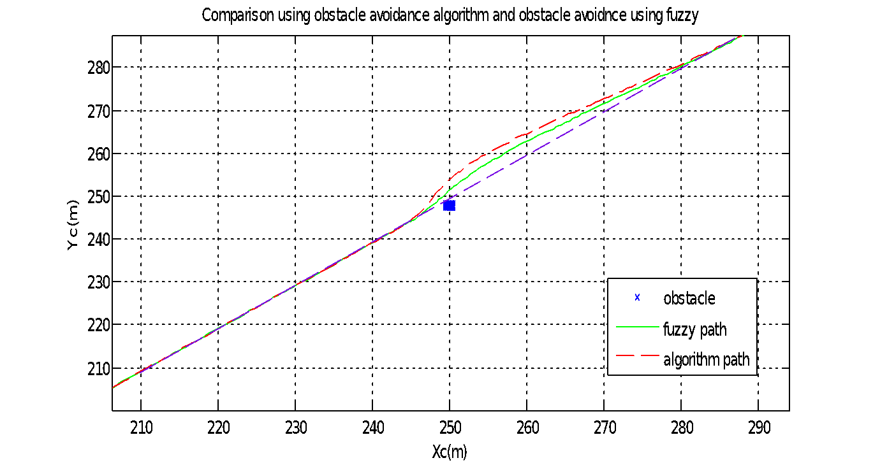
Fig.5.3. Comparison between tracking with obstacle avoidance algorithm and algorithm using fuzzy

HARDWARE

Block Diagram
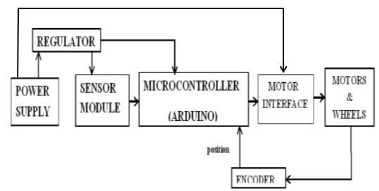
Figure6.1 Block diagram of hardware
Figure 6.1 shows the main power supply 9V Battery is given to the regulator which gives regulated 5V, which in turn is given as the supply for sensors and microcontroller. The output of microcontroller is given as the inputs for the motor driver IC that drives the two dc motors which are connected to the wheels used to move the robot. The speed of the motor is obtained from the encoder and fed back to the microcontroller to get the position of the robot.

Components

Power Supply
A constant 9V DC supply used to drive the robot.

Regulated IC 7805
IC 7805 is a voltage regulator integrated circuit which provides regulated output voltage in the range 4.8V-5.2V for an input in the range 5V-18V. It is a member of 78xx series of fixed linear voltage regulator ICs which use 10microF capacitor as output while 100microF as input. The pinout diagram for L7805 IC is shown below.
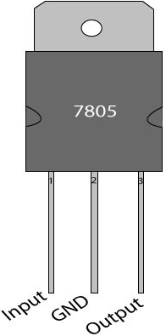
Fig.6.2 Pinout of L7805

Speed Encoder
Encoding is used to get the velocity of the robot from the wheel rotation. For obtaining 18 pulses for a complete rotation, 18 alternate black and white strips are drawn on wheel.
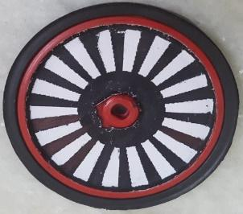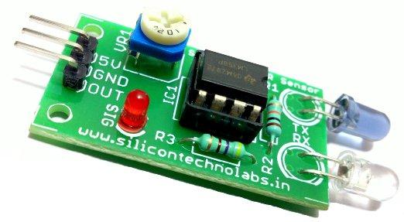Figure.6.3 Wheel with encoding strips Figure.6.4 IR sensor

The white strip reflects the IR rays emitted by IR transmitter which inturn are sensed by the IR receiver in the sensor. Hence pulses are obtained when the sensor traverse the alternate white and black strips
For calculation of velocity, number of pulses is taken as 18.
18pulses=1revolution=2*π*r=2*3.14*3.4cm=
21.352 ~ 21cm. (6.1)
1 pulse = 21/18 = 1.16cm = 0.0116m. (6.2)
If time for 1 pulse = 1ms = 0.001s (6.3)
d= 0.0116m, t= 0.001s (6.4)
V= d/t = 0.0116/0.001 = 11.6m/s. (6.5)

IR Range Sensors
These are used for measuring the distance to an object using optical sensors by triangulation measuring method. The sensors have IR LED equipped with lens, which emits narrow light beam. After reflecting from the object, the beam will be directed through the second lens on a position-sensible photo detector (PSD) whose conductivity which is converted to voltage, depends on the position where the beam falls. If the voltage is digitalized by using analogue-digital converter, the distance can be calculated. The output of distance sensors is inversely proportional.
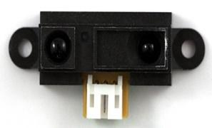
Figure 6.5 IR range sensor
When measuring objects which are too far, the output remains approximately the same as it is when measuring the objects at the maximum distance. Minimum distance is restricted due to peculiarity of sharp sensors, so make sure that object is not too close to the sensor.
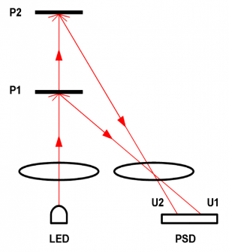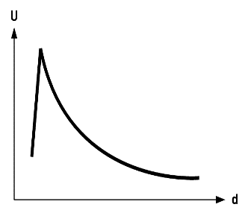
Figure 6.6 Working principle Figure6.7. Characteristic plot
of IR of IR
Figure 6.7 shown above indicates the variation of analog voltage w.r.t distance. The distance is inversely proportional to voltage. Min. distance of IR sensor = 10cm and max. distance = 80cm.

Calibration of IR Range sensors
In order to calibrate, voltage corresponding to the distances is calculated using ADC conversion
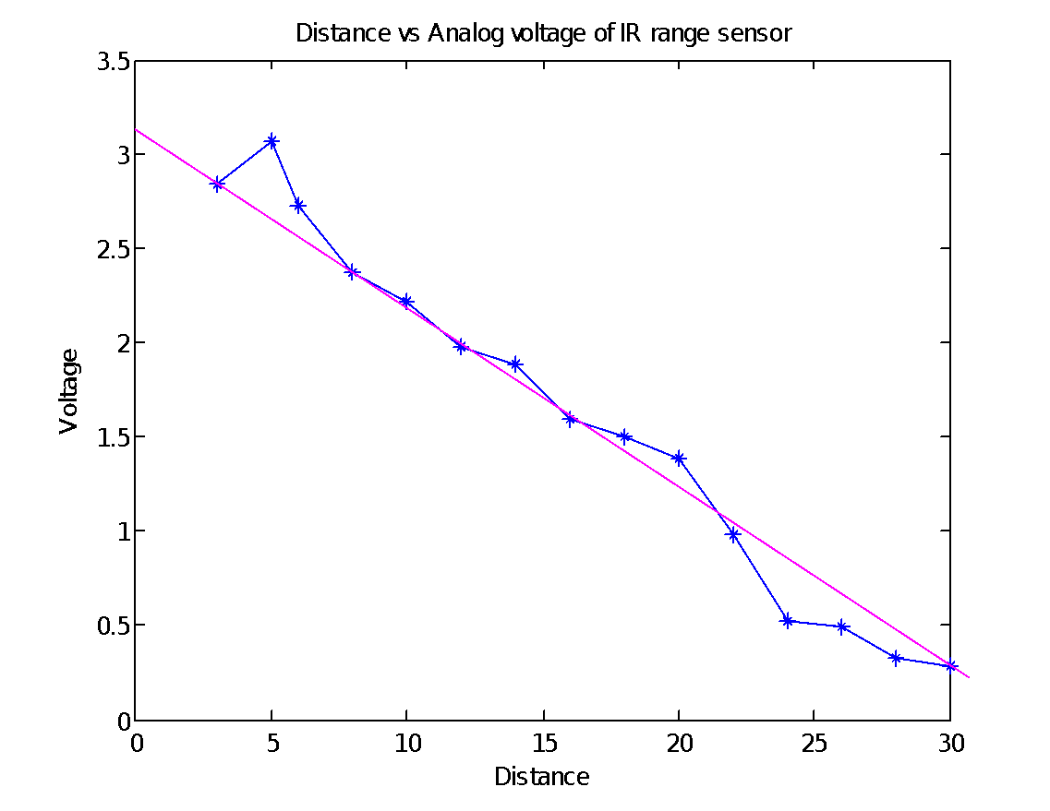
Figure 6.8 Calibration curve for voltage v/s distance plot
From figure 6.8, calibrated equation for distance can be formed by finding the slope and y intercept. For linear approximation, outer points are neglected.

Distance, D= (V-3.16)/-0.1 (6.6)

Microcontroller- Arduino

The microcontroller used is Arduino UNO board based on the ATmega328P. It has 14 digital input/output pins, 6 analog inputs, a 16 MHz quartz crystal etc. It contains everything needed to support the microcontroller; connect it to a computer with a USB cable or power it with AC-to-DC adapter or battery to get started.
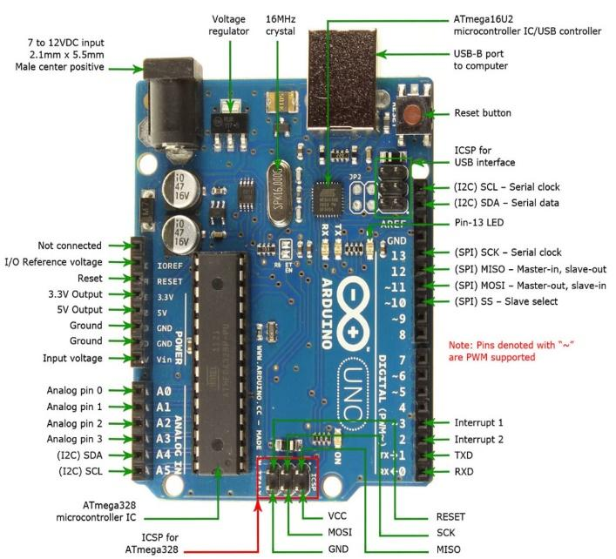
Figure 6.9 Pin diagram of arduino Uno

L293D Motor Driver IC

It is a dual H-bridge motor driver integrated circuit (IC) which act as current amplifiers. This higher current signal is used to drive the motors. Two DC motors can be driven simultaneously, both in forward and reverse direction by input logic at pins 2 & 7 and 10 & 15. Enable pins 1 and 9 must be high to enable the associated driver. As a result, the outputs become active and work in phase with their inputs.
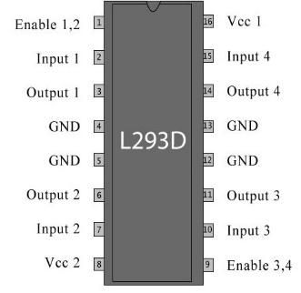
Fig.6.10 Pin diagram of L293D IC

For rotating the motor in a particular direction, the input pins has to be provided with particular logic.
• Pin 2 = Logic 1 and Pin 7 = Logic 0 | Clockwise Direction
• Pin 2 = Logic 0 and Pin 7 = Logic 1 | Anticlockwise Direction
• Pin 2 = Logic 0 and Pin 7 = Logic 0 | Idle [No rotation] [Hi-impedance state]
• Pin 2 = Logic 1 and Pin 7 = Logic 1 | Idle [No rotation]
The motor can also operate across input pin 15, 10 for motor on the right hand.
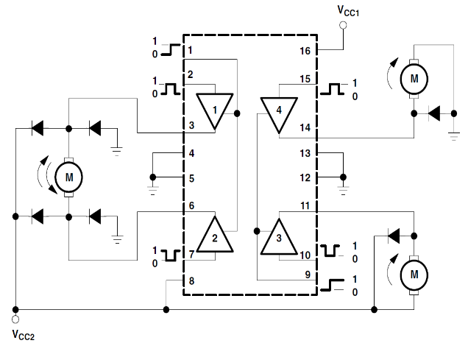
Figure 6.11 Working diagram of L293D

DC motor

Two 9V DC motors are used to drive the robot. Its speed can be reduced to any desirable figure by gear reduction.
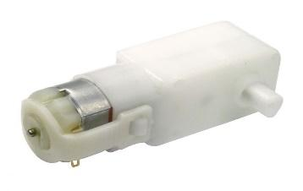
Figure 6.12 DC motor

Its specifications are:
Voltage(v) | 3-9v
Current | 0.01a (no load); 0.07a (at max. eff.)
Locked-rotor current | >=0.15a
Speed(rpm) | 60rpm+-10%(no load)
Torque | 0.5kg-cm
Rotation | cw/ccw

Wheels

Wheels are locked to motor shaft which is 6.8cm in diameter and castor which is a passive self- adjusting wheel which balances the robot while in motion.
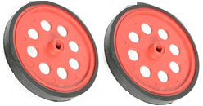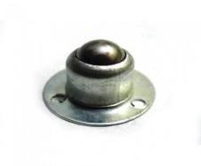
Figure 6.13 Wheels Figure 6.14 Castor Wheel

Hardware Description

The power supply of 9V is given to the regulator IC (LM7805) which provides regulated 5V supply for the IR range sensors and the enable pins of the motor driver IC (L293D). The microcontroller is given an input voltage of 9V. Three analog inputs from the IR range sensors, two digital inputs from the speed encoding IR sensors are fed to the microcontroller. These data are processed and the output is given to the PWM pins ( depends on duty ratio) according to which the motor moves forward, turn left or turn right or stop. The motor is attached to wheels. The robot is balanced by a castor wheel which adjusts itself to comfort the robot motion.
The values of PWM corresponding to duty cycle is shown below.
0 – 5V - 0 – 255
100% duty cycle – 255
75% duty cycle – 191
50% duty cycle – 127

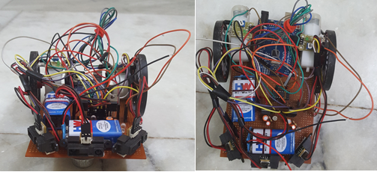
Figure 6.15. Front view and top view of hardware model

CONCLUSION AND FUTURE SCOPE

Literature survey on various papers resulted in finding that fuzzy design suited the best for fast response time.
In this project, path tracking with obstacle avoidance algorithm and path tracking with obstacle avoidance algorithm using fuzzy are discussed and their performances are analysed. For efficient tracking, switching algorithm could give a better result. A switching scheme between the algorithms is done to reduce complexity.
Carrot chasing algorithm [6] adapts the simple method of path following. Introducing a VTP in the path and mobile following, it makes the method simpler to implement and it allows the robot to enter its desired predefined path quickly. Also, loiter tracking was explained using the CCA algorithm.

In obstacle avoidance algorithm, the steps to avoid obstacles are designed by the orientation of the sensors attached to the mobile robot that provide information by indicating difference in the distance measured. Minimum distance was taken into consideration. This method efficiently avoided the obstacles but was not adaptable to uncertainties caused by the sensors.
To avoid the uncertainties caused by the sensors, a fuzzy based obstacle avoidance algorithm was designed. T-S fuzzy inference system was used to frame the rule base. This design indicated the sensor noises as difference in distances detected by the sensors. Thus, it reduced the effect of sensor noises.
Comparison between the path tracking with obstacle avoidance using algorithm and tracking with obstacle avoidance using fuzzy logic was done. From the simulation results, it was seen that the deviation of fuzzy path is much less compared to the algorithm path and the memory size is less since the obstacle or the path is not saved. The time taken by the fuzzy path to reach back to the desired path is less compared to the algorithm path.
Hardware implementation is done with a differential drive wheeled robot. IR sensors are used for obstacle detection. Tracking is done using CCA and obstacle avoidance is done using fuzzy. Switching between tracking and obstacle avoidance using fuzzy logic is implemented and the results were observed.
Future scope of this project is that the design can be modified to avoid moving obstacles.

